Experiment No. 4
Time-division multiplexing (TDM)
Object:
- To study and understand the principle of Time-division multiplexing (TDM).
- To learn how to implement Time-division multiplexing (TDM) system using Matlab-Simulink.
Theory:
Time-division multiplexing (TDM) is a method of transmitting and receiving independent signals over a single communication channel by means of synchronized switches at each end of the transmission line by dividing the time frame into slots – one slot for each message signal. Time-division multiplexing is primarily applied to digital signals as well as analog signals, wherein several low speed channels are multiplexed into high-speed channels for transmission. It is used when the bit rate of the transmission medium exceeds that of the signal to be transmitted. This form of signal multiplexing was developed in telecommunications for telegraphy systems in the late 19th century, but found its most common application in digital telephony in the second half of the 20th century.
In Digital Multiplexing, several low bit-rate signals can be multiplexed or combined, to form one high bit-rate signal, to be transmitted over a high frequency medium. Because the medium is time-shared by various incoming signals, this is a case of TDM. Multiplexing can be done on a bit-by-bit basis (known as digit interleaving), or on a word-by-word basis (known as byte or word-interleaving). At both the ends, i.e., the multiplexer and demultiplexer are timely synchronized and simultaneously switched to the next channel as shown in Figure 1.
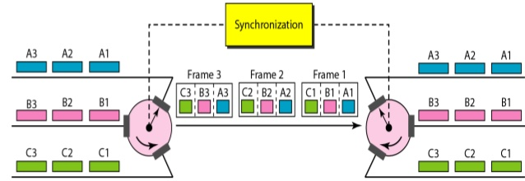
Figure 1. Interleaving Time-division multiplexing transmitter and receiver

At the receiving terminal, the incoming digit stream must be divided and distributed to the appropriate output channel. For this purpose, the receiving terminal must be able to correctly identify each bit. This requires the receiving system to uniquely synchronize in time with the beginning of each frame, with each slot in a frame and with each bit within a slot. This is accomplished by adding framing and synchronization bits to the data bits. These bits are part of the so-called overhead bits.
Sampling of signals is needed for applications such as time–sharing of a signal transmission facility, i.e. time–division multiplexing (TDM). The signal samples may be used in analogue form, e.g. using pulse–amplitude modulation (PAM), or they may be quantized and encoded into digital form, i.e. pulse–code modulation (PCM).
Since the purpose of TDM is to exploit better the available performance of a signal transmission facility by squeezing as many channels into it as practically possible, this objective will be best achieved by using as few samples as possible per unit time per channel. For this reason, it is important to know the minimum sample rate needed to avoid excessive distortion, and also to avoid placing unrealistic or costly demands on the performance of the functional elements of the system (e.g. transition bandwidth of anti–aliasing and interpolation filters). These considerations apply not only to TDM systems, but in fact to all sampled–data signal processing systems, which includes all digital processing of analogue data, e.g. digital filtering, digital spectrum analysis.
Figure 4 Generation TDM Waveform
The sampling theorem provides a theoretical basis for estimating a minimum sampling rate in these situations. It is assumed that this theorem will have been studied before the experiment is attempted.

Applications of TDM
The first TDM was developed for telegraphy application. Using this system, multiple data transmission were routed over a single transmission line. Nowadays TDM is used for many applications which are given below.
1. TDM is used in digital audio mixing system.
2. TDM or Time Division Multiplexing is used in Pulse Coden Modulation(PCM) transmission system.
3. In the optical data transmission system or optical fiber communication, Time Division Multiplexing mostly used.
4. Time Division Multiplexing or TDM is used in SONET(Synchronous Optical Networking)
5. Time Division Multiplexing or TDM is used in landline phone system such as Signaling System 7 or SS7. Here up to 24 separate phone calls or phone conservation can be multiplexed and demultiplexed.
6. In Half Duplex Communication system, TDM or Time Division Multiplexing is used.
7. Time Division Multiplexing is used in Integrated Service Digital Network or ISDN telephone system.
8. TDM also used in Public Switched Telephone Network or PSTN system.
9. TDM is used in Synchronous Digital Hierarchy or SDH system.
10. TDM is used in GSM or Global System for Mobile communication technology.
11. TDM is used in Satelite Acess system.
12. TDM is used in Cellular Radio.

Advantages of TDM
The main advantages of Time Division Multiplexing (TDM) are:
1. The hardware required for TDM is very less.
2. TDM circuits are not so complex than other systems like Frequency Division Multiplexing or FDM. It is a great advantage of TDM over FDM.
3. In the TDM system, the full bandwidth of a channel can be used.
4. TDM has dynamic coordination.
5. TDM provides more throughput than FDM.
6. Another great advantage of TDM is that TDM mainly used for Digital Signals but it also can be used for analog signals.
7. TDM provides higher efficiency than FDM as it has dynamic coordination.
8. TDM system does not need any carrier wave or carrier signal but FDM need a carrier signal which divides the main signal according to frequency.
9. There is no intermodulation distortion.

Disadvantages of TDM
The main disadvantages of Time Division Multiplexing (TDM) are:
1. TDM needs synchronization but FDM does not need synchronization. It is a disadvantage of TDM over FDM.
2. Another noticeable disadvantage of TDM is that TDM provides less latency than FDM.
3. In Time Division Multiplexing system, address information and buffer is needed.

Types of TDM
Time division multiplexing is classifieds into four types:
- Synchronous time-division multiplexing
- Asynchronous time-division multiplexing
- Interleaving time-division multiplexing
- Statistical time-division multiplexing

Synchronous Time Division Multiplexing
Synchronous time division multiplexing can be used for both analog and digital signals. In synchronous TDM, the connection of input is connected to a frame. If there are ‘n’ connections, then a frame is divided into ‘n’ time slots – and, for each unit, one slot is allocated – one for each input line. In this synchronous TDM sampling, the rate is same for all the signals, and this sampling requires a common clock signal at both the sender and receiver end. In synchronous TDM, the multiplexer allocates the same slot to each device at all times.
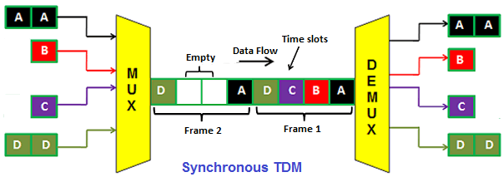
Figure 2 Synchronous time division multiplexing

Asynchronous Time-Division Multiplexing
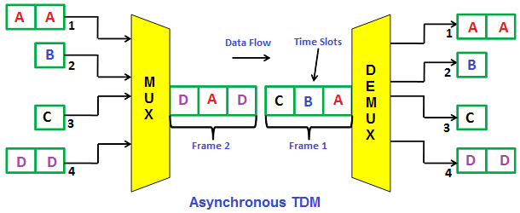
In asynchronous time-division multiplexing, the sampling rate is different for different signals, and it doesn’t require a common clock. If the devices have nothing to transmit, then their time slot is allocated to another device. Designing of a commutator or de-commutator is difficult and the bandwidth is less for time-division multiplexing. This type of time-division multiplexing is used in asynchronous transfer mode networks.
Figure 3 Asynchronous time division multiplexing

Interleaving
Time-division multiplexing can be visualized as two fast rotating switches on the multiplexing and demultiplexing side. At the same speed these switches rotate and synchronize, but in opposite directions. When the switch opens at the multiplexer side in front of a connection, it has the opportunity to send a unit into the path. In the same way, when the switch opens on the demultiplexer side in front of a connection that has the opportunity to receive a unit from the path. This process is called interleaving as shown in Figure 1.

Statistical Time-Division Multiplexing
Statistical time-division multiplexing is used to transmit several types of data concurrently across a single transmission cable. This is often used for managing data being transmitted via LAN or WAN. The data is simultaneously transmitted from the input devices that are connected to the network including printers, fax machines, and computers. This type of multiplexing is also used in telephone switch board settings to manage the calls. Statistical TDM is similar to dynamic bandwidth allocation, an in this type of time-division multiplexing, a communication channel is divided into an arbitrary number of data streams.
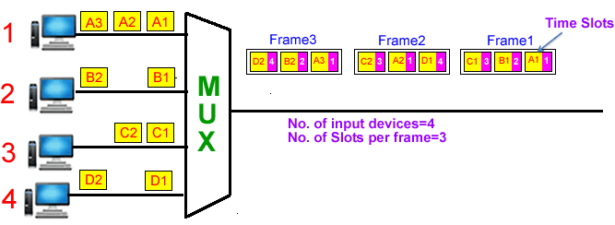
Figure 5 Statistical time-division multiplexing

Procedure
- Implement the 4-TDM Multiplexer and Demultiplexer shown in Figure 7.
- we used sine wave, Square function, Ramp function, and sawtooth function generators as inputs to TDM Multiplexer. Then we used pulse generator with Delay components to control on selecting signals by the multiplexer.
- Set the parameters of four signals:
Sine wave
Amplitude: 1, Frequency (rad/sec):4*2*π
Repeating Sequence
Time Values: [0 0.5], Output Values: [0 2]
Signal Generator
Wave Form: sawtooth, Amplitude: 1, frequency: 10, Units: Hertz
Signal Generator
Wave Form: Square, Amplitude: 1, frequency: 10, Units: Hertz
- Set the parameters of the pulse generator with the amplitude 1, the period 0.001 (frequency 1000 Hertz) and the pulse width (%) 25%.
- We used Delays to allow us to obtain samples from each signal in sequence as shown in Figure 6.

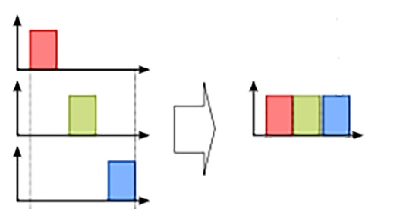
Signal 1
Signal 2
Signal 3
TDM

Figure 6 Multiplexing the signals ‘samples

- From point 4, the pulse width is 25%*0.001 (0.00025), Therefore, we set the parameters of Delays with delay value 0.00025. Delay 1 delayed the pulse by 0.00025, Delay 2 by 2*0.00025 and Delay 3 by 3*0.00025.
- Set the parameters of the Multiplexer and Demultiplexer with Number of inputs by 4.
- Set the parameters of Analog Filter Design as follows:
Design method: Butterworth, Filter type: Lowpass, Filter order: 8, Passband edge frequency(rad/sec): 10*2*π
- Build the structure of Constructor as shown in Figure 8 and set the parameters of Delays by 0.00025.
- Plot the signals in each scope.
Part B:
- Implement the 4-TDM Multiplexer and Demultiplexer shown in Figure 7.
- Repeat the setting of the parameters of the components as shown in Part A.
- Replace the constructors with lowpass filters with setting the parameters of Analog Filter Design as follows:
- Design method: Butterworth, Filter type: Lowpass, Filter order: 8, Passband edge frequency(rad/sec): 2000*2*π
Notice: 1 Radian per second is comparative to 1/2π Hertz
- Plot the signals in last scope.
Figure 7 TDM Modulator and Coherent Demodulator
Figure 8 Structure of Constructor
Discussion
- From the results, explain the effect of using lowpass filter instead of constructors
- What is the maximum pulse rate (frequency)?
- What are the types of Time division multiplexing? Explain each type.
- Can we use TDM in analogue and digital forms? Explain that.
- Mention three applications of TDM that you touch them?
- Mention three advantages and three disadvantages of TDM?

